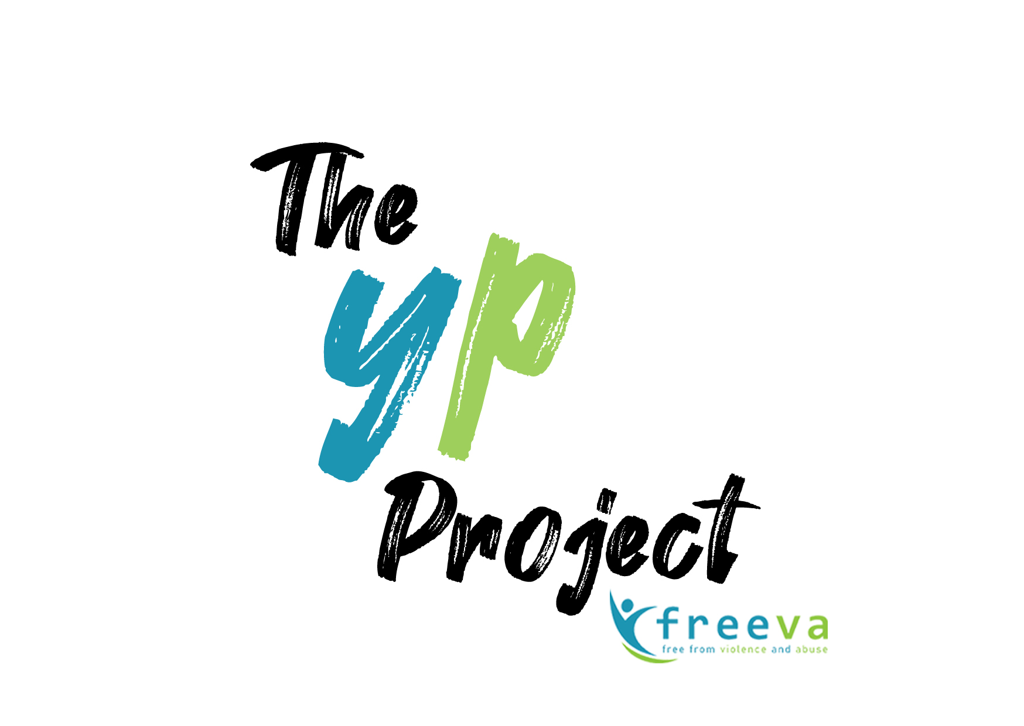
Job Description

Job title: | Interventions Worker
Scale: | £25,000.00-£27,447.00 (dependant on experience)
 | 3% employer’s contribution
Responsible to: | The YP Project - Service Manager
Hours | 35 Hours per week

Main purposes of the post:
- To work directly with young people aged 10-18 years to address adolescent to parent violence and abuse (APVA) and/or Intimate Partner Violence and abuse (IPV) within young people’s relationships in line with the standards of Respect.
- To work directly with parents/carers and/or partners who are experiencing APVA/IPV.

Main duties:
Client Work and Liaison
- Engage and motivate families and young people to address issues around APV/IPV.
- Conduct suitability, risk and support planning assessments with families.
- Deliver group work /1-2-1 sessions with both young people and parents/
carers as outlined in the delivery manuals.
- Contribute to and inform case management procedures as required and implement required actions and assess risk.
- Comply with Safeguarding and child protection procedures and practices.
- Plan appropriate exit strategies for families on programme completion.
- To liaise with other agencies as appropriate including but not limited to CYPS, Police, CAMHS, YOS, specialist DV agencies and schools.
- To attend professional meetings, child in need/child protection core groups etc with above agencies to feedback on client work and progress.

- To assist in presentations, workshops and training about the work of The YP Project and The Jenkins Centre.
- To assist in representing The YP Project and the Jenkins Centre as required at meetings, seminars and conferences.

Administration
1.To assist with collecting information needed for funding purposes.
2. To assist the Service Manager in producing statistical and other reports on work done within The YP Project to meet the requirements of commissioners and co-operating in the ongoing evaluation of the The YP Project and FREEVA services.
3. To maintain appropriate client records in line with confidentiality and data protection procedures.

Other
1.To attend and contribute to team meetings.
2. To attend line management supervisions s as requested and to provide information on client work, service delivery and organisational issues to the line manager.
3. To implement decisions agreed in line management meetings.
4. To participate in development policy, strategies and working practices of The YP Project by attending meetings and giving feedback as appropriate to others doing this work.
5. To actively participate in the local forums, conferences supporting the development of effective responses to domestic violence.
6. To assist with general cover of the FREEVA office.
7. To conduct all work in a way that reflects the aims and principles of The YP Project, in particular the centre’s policies on anti-discriminatory practice, equal opportunities and confidentiality.
8. To keep up to date with domestic violence issues and participate in relevant training as required
9. To undertake other duties as reasonably requested.

Person Specification- Young Person’s Intervention Worker

Area | Criteria
Education & training | Essential  A level 4 or equivalent qualification (or alternatively significant relevant experience) is essential.  Desirable  A relevant professional qualification in Social Work, Youth & Community Work, Counselling, Criminology or Teaching.
Experience & Knowledge | Essential  - An understanding of the nature of domestic violence and its effects on family units.  - Experience in working with Young people and their families or support systems.  - An understanding of the child protection system.  - Knowledge of and familiarity with Microsoft Office applications including Word, PowerPoint and Excel.  - A competent user of Outlook and the Internet.  - Ability to use computerised monitoring systems.  - Experience in using client management systems such as Oasis or similar.  Desirable:  - An understanding of risk factors in perpetrators of domestic violence.  - An understanding of domestic violence in the context of women’s violence towards male partners, domestic violence in same sex relationships, young people’s violence towards parents and so called honour based violence.  - Understanding of the criminal justice system, CAMHS, behaviour support options relating to young people using violence and abuse.  - Understanding of Early Help and Whole Family Assessments.  - Experience of liaising with social workers and other professionals from a range of statutory and voluntary agencies.
Personal Attributes | Essential  - The ability to communicate clearly with a range of people both over the telephone, through email and in person, sometimes over sensitive and/or complex issues.  - The ability to work with young people and understand their eco-systems, culture and mindset.  - Motivated and enthusiastic.  - Ability to operate with a high degree of confidentiality.  - Ability to work to tight deadlines and to take responsibility for meeting agreed targets.  - Ability to work on own initiative, to be proactive and take responsibility for workload.  - Ability to work independently and as part of a team towards a common objective  - Commitment to continuing professional development  - Ability to recognise discrimination, in its various forms, and to take appropriate action  - Willingness to work flexibly, as and when required  - The ability to manage your own administration and to maintain effective administrative systems.
Attitude | Essential:  - Demonstrate an understanding of Anti-Discriminatory Practice in service delivery and a commitment to implementing Anti-Discriminatory Practice in relation to job responsibilities.  - Demonstrate an understanding of and a commitment to work in accordance with the Confidentiality and Equal Opportunities Policies of The YP Project.  - Demonstrate an understanding of and commitment to work in accordance with the objectives and principles of the Respect Service Standard.  - Demonstrate a willingness to work within an organisation which works both with perpetrators of and with victims who have experienced domestic violence.  - Demonstrate a willingness and ability to work flexibly including some evenings.  - Demonstrate an understanding and willingness to deliver the service in collaboration with other agencies.

For further information about the service contact: Danielle, Service Manager, The YP Project
danielle@freeva.org.uk or visit our website: www.jenkinscentre.org
0116 254 0101

